**ACKNOWLEDGEMENT**

It is with great enthusiasm and learning spirits that we are bringing out this project report. Before we get into the thick of things, on this joyful occasion, we presentour whole hearted complements with high regards and warm thanks to one and all whoare the bone behind the sinews of this project.We give all glory and honour to Almighty God whose blessings made thisendeavour a success.We are extremely grateful to the Principal in charge

**Mr. Raveendran**

for having provided us with all the facilities required for successful completion of the project.It is our great pleasure to express our gratitude to

**Prof. Ashok Hegde. L**

, Head of electronics and Communication Department for his kind support and valuable advice for the project work.With immense pleasure and heartiest gratitude, we express our sincere thanks toour project in

**Mrs. Namitha**

, for her valuable suggestions and guidance.We are sincerely thankful to

**Miss. Divya**

and

**Miss. Nishitha**

for their valuablesuggestions and guidance.We honestly express our indebtness to the teaching and non- teaching staff of ECEDepartment for their valuable guidance, help co-operation and continued encouragementin each and every step of this project.Last but not least, we are indebtness to our parents for their constantencouragement and support. We gladly dedicate this mini project to our most loving andsupportive parents.

**ABSTRACT**

This circuitry system is used for controlling a home appliance circuit by bluetooth module and symbian OS mobile.In this device we mainly use a mobile phonehaving symbian OS facility such like N serirs Nokia mobiles.This mobile phone that weusing as remote to controlling the circuitry system.We use a blue tooth module as receiver.In this circuit diagram it is show that amicrocontroller is embedded with the blue tooth module,and this is pre-programmed for controlling the circuitry.And there is also a Relay driver IC for passing the output of themicrocontroller to the relay circuit.

**INTRODUCTION**

Device control through Bluetooth from symbian os mobile use your symbian osmobile to control devices through Bluetooth. The serial to bluetooth converter fromsparksun.com is used in this project. The micro controller AT89c2051 is used to receivethe data from the mobile through Bluetooth. Most of the Nokia smart phones can be usedin this project.Our project aims at data acquisition and based on the data acquired thecontrol of the switching action of any device attached to the circuit. Data is transferred between two Bluetooth enabled devices, one act as the server and other as the client. Allthe controlling action is done by mobile phone. The technology used (bluetooth) is wireless and inexpensive and uses anunlicensed radio spectrum with the main disadvantages being the range of operation.Bluetooth has a range of only 10m in closed spaces and 20m in the open therebyrestricting the operational area.

***Dept of ECE***

1

***SNGCET Payyanur***

**BLOCK DIAGRAM**

***Dept of ECE***

2

***SNGCET Payyanur***

MOBILE PHONEBLUETOOTHMODULEMICROCONTROLLER RELAYSUPPLYTRANSMITTER &CONTROLLER RECEIVER

**BLOCK DIAGRAM DESCRIPTION**

The basic block diagram mainly consisting a transmitter stage & receiver stage.Mobile phone will acts as transmitter & microcontroller will acts as receiver. The Datatransmission between transmitter & receiver is taking through the Bluetooth module. Thestatus from the relay is transmitted to mobile through Bluetooth module and process of controlling is taking place in mobile phone which is our controller.

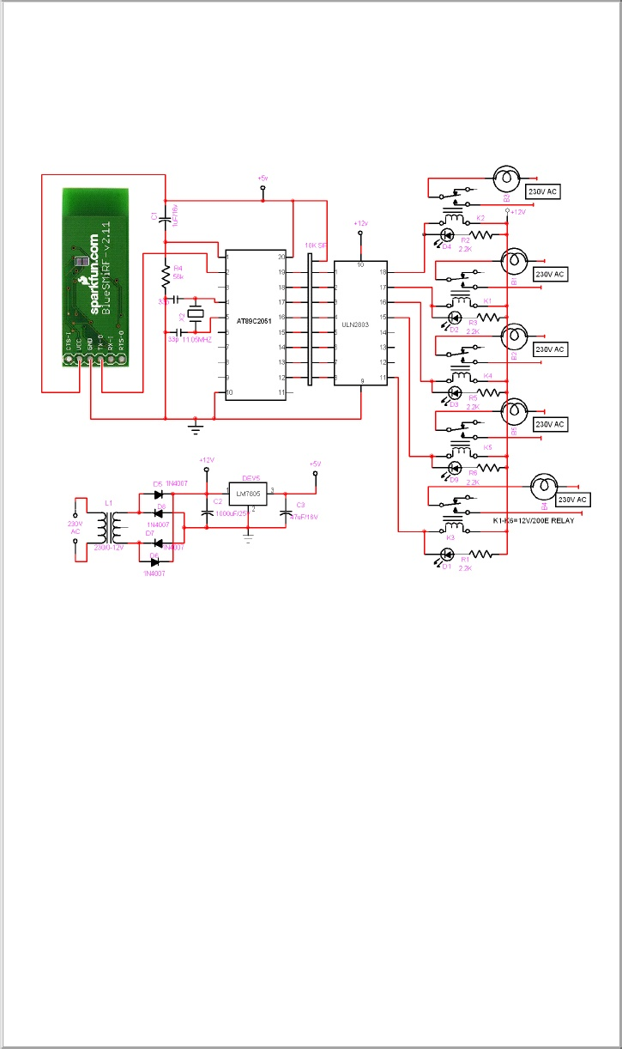

**CIRCUIT OPERATIONS**

Communication through Bluetooth module is the basic principle used in thiscircuit.Here Bluetooth module and mobile phone will act as a trans receiver. Mobile phone will give instruction to microcontroller through Bluetooth module. For controllingthe relay circuit and it will receive information from microcontroller through Bluetoothmodule about the status of the relay. The Bluetooth module will receive data from bothmobile phone & microcontroller. The Blue SMIRF V.2.11 bluetooth module is used here.Mobile phone operation will control by the python software which is installed inthe mobile phone. The relay is controlled by the programmed AT 89c2051microcontroller. ULN2803 is the IC we are using to drive the relay.Bluetooth module cannot receive information parallelly. So the parallelinformation must convert to serial data. So a SIP is used which convert the parallel datafrom relay driver to serial data.The instruction from mobile phone will receive by Bluetooth module and transfer in to microcontroller and the microcontroller will send this data to relay driver and willcontrol the relay. The relay will send the status to micro controller and will convert datain to serial and transfer it to mobile phone through Bluetooth module.

**TECHNOLOGY USED – BLUETOOTH**

Bluetooth is a specification for a small form-factor, low-cost radio solution providing links between mobile computers, mobile phones and other portable handhelddevices, and connectivity to the Internet. It will enable users to connect a wide range of computing and telecommunications devices easily and simply, without the need to buy,carry, or connect cables.It is a wireless technology that operates on an unlicensed radio spectrum. Thereis no charge for communicating between two Bluetooth devices. Bluetooth is intended toget around the problems that come with both infrared and cable synchronizing systems.The hardware vendors, which include Siemens, Intel, Toshiba, Motorala and Ericsson,have developed a specification for a very small radio module to be built into computer,telephone and entertainment equipment. From the user’s point of view, there are threeimportant features to Bluetooth:1.Its wireless. When you travel, you don’t have to worry about keeping track of a briefcase full of cables to attach all of your components, and you can design your office without wondering where all the wires will go.2.It’s inexpensive.3.You don’t have to think about it. Bluetooth doesn’t require you to do anythingspecial to make it work. The devices find one another and strike up aconversation without any user input at all.It is a wireless protocol that is used to communicate from one device to another ina small area usually less than 30 feet. Bluetooth communicates on a frequency of 2.45gigahertz, which has been set aside by international agreement for the use of industrial,scientific and medical devices (ISM). Bluetooth’s founding members include Ericsson,IBM, Intel, Nokia and Toshiba.Bluetooth was designed to allow low bandwidth wireless connections to becomeso simple to use that they seamlessly integrate into your daily life. A simple example of a

Bluetooth application is updating the phone directory of your mobile phone. Today, youwould have to either manually enter the names and phone numbers of all your contacts or use a cable or IR link between your phone and your PC and start an application tosunchronize the contact information. With Bluetooth, this could all happen automaticallyand without any user involvement as son as the phone comes within range of the PC! Of course, you can easily see this expanding to include your calendar, to do list, memos,email, etc. This is just one of many exciting applications for this new technology! Canyou imagine walking into a store and having all the sale items automatically available onyour cell phone or PDA? It is a definite possibility with Bluetooth.

**System Architecture**

Bluetooth communication occurs in the unlicensed ISM band at 2.4 GHz. This isan unlicensed band and, in most countries, includes the frequency range from 2400 to2483.5 MHz. of course, as always when dealing with international standards, there are afew exceptions. The primary geographies with exceptions are France (2446.5 to 2483.5MHz) and Spain (2445 to 2475 MHz). The transceiver utilizes frequency hopping toreduce interference and fading. A typical Bluetooth device has a range of about 10meters. The communication channel can support both data (asynchronous) and voice(synchronous) communications with a total bandwidth of 1 Mb/sec. The supportedchannel configurations are as follows:

**ConfigurationMax. Data RateUpstreamMax. Data RateDownstream**

3 Simultaneous VoiceChannels64 kb/sec X3 channels64 kb/sec X3 channelsSymmetric Data433.9 kb/sec433,9 kb/secAsymmetric Data723.2 kb/sec or 57.6 kb/sec57.6 kb/sec or 723.2 kb/secThe synchronous voice channels are provided using circuit switching with a slotreservation at fixed intervals. A synchronous link is referred to as an SCO (synchronousconnection-oriented) link. The asynchronous data channels are provided using packetswitching utilizing a polling access scheme. An asynchronous link is referred to as an

ACL (asynchronous connection-less) link. A combined data-voice SCO packet is alsodefined. This can provide 64 kb/sec voice and 64 kb/sec data in each direction.Bluetooth devices can interact with one or more other Bluetooth devices in severaldifferent ways. The simplest scheme is when only two devices are involved. This isreferred to as point-to-point. One of the devices acts as the master and the other as aslave. This ad-hoc network is referred to as a piconet.

**Bluetooth Modem - BlueSMiRF Gold**

**sku: WRL-00582Description:**

The BlueSMiRF is the latest Bluetooth

**®**

wireless serial cable replacementfrom SparkFun Electronics! These modems work as a serial (RX/TX) pipe. Any serialstream from 9600 to 115200bps can be passed seamlessly from your computer to your target. We've tested these units successfully over open air at 350ft (106m)!The remote unit can be powered from 3.3V up to 6V for easy battery attachment.All signal pins on the remote unit are 3V-6V tolerant. No level shifting is required.

**Do not**

attach this device directly to a serial port. You will need an[RS232 to TTL converter](http://www.sparkfun.com/commerce/present.php?p=BEE-4-UART) [circuit](http://www.sparkfun.com/commerce/present.php?p=BEE-4-UART)if you need to attach this to a computer.

**Specifications:**

•

FCC Approved Class 1 Bluetooth

**®**

Radio Modem

•

Extremely small radio - 0.15x0.6x1.9"

•

Very robust link both in integrity and transmission distance (100m) - no more buffer overruns!

•

Low power consumption : 25mA avg

•

Hardy frequency hopping scheme - operates in harsh RF environments like WiFi,802.11g, and Zigbee

•

Encrypted connection

•

Frequency: 2.4~2.524 GHz

•

Operating Voltage: 3.3V-6V

•

Serial communications: 2400-115200bps

•

Operating Temperature: -40 ~ +70C

**PROGRAM**

INCLUDE REG_51.PDFLOAD1EQUP1.0LOAD2EQUP1.1LOAD3EQUP1.2LOAD4EQUP1.3LOAD5EQUP1.4LOAD6EQUP1.5LOAD7EQUP1.6LOAD8EQUP1.7DSEG ; This is internal data memoryORG 20H ; Bit adressable memoryMOBILE:DS3COUNTER:DS1CSEG ; Code begins here; ---------==========----------==========---------=========---------; Main routine. Program execution starts here.

; ---------==========----------==========---------=========---------ORG 00H ; ResetAJMP MAINORG 0023HAJMP SERIAL; ---------==========----------==========---------=========---------MAIN: MOV SP,#40HMOV TMOD,#20H;initilize serial portMOV TH1,#0FDH;Slect 9600 baud rateMOV SCON,#50HMOV A,PCONSETB ACC.7MOV PCON,AMOV IE,#10010000BSETB TR1;start timer MOV COUNTER,#00HMOV P1,#00HAJMP $;**************************************************************************SERIAL:JB TI,TRAS1MOV A,SBUF

CJNE A,#'A',DOWNWMOV COUNTER,#00HAJMP DOWN1TRAS1:AJMP TRASDOWNW:CJNE A,#0AH,DOWNW1CALL DEVICE_DECODEAJMP DOWN1DOWNW1:MOV A,COUNTER CJNE A,#01H,SD1MOV MOBILE,SBUFAJMP DOWN1SD1:CJNE A,#02H,DOWN1MOV MOBILE+1,SBUFDOWN1:INC COUNTER CLR RIRETITRAS: CLR TIRETI;**************************************************************************DEVICE_DECODE:MOV A,MOBILE;LOAD 1CJNE A,#31H,SDF1MOV A,MOBILE+1CJNE A,#31H,SDF2

SETB LOAD1AJMP SDF1SDF2:CJNE A,#32H,SDF1CLR LOAD1SDF1:MOV A,MOBILE;LOAD 2CJNE A,#32H,SDF11MOV A,MOBILE+1CJNE A,#31H,SDF21SETB LOAD2AJMP SDF11SDF21:CJNE A,#32H,SDF11CLR LOAD2SDF11:MOV A,MOBILE;LOAD 3CJNE A,#33H,SDF12MOV A,MOBILE+1CJNE A,#31H,SDF22SETB LOAD3AJMP SDF12SDF22:CJNE A,#32H,SDF12CLR LOAD3

SDF12:MOV A,MOBILE;LOAD 4CJNE A,#34H,SDF14MOV A,MOBILE+1CJNE A,#31H,SDF24SETB LOAD4AJMP SDF14SDF24:CJNE A,#32H,SDF14CLR LOAD4SDF14:MOV A,MOBILE;LOAD 5CJNE A,#35H,SDF15MOV A,MOBILE+1CJNE A,#31H,SDF25SETB LOAD5AJMP SDF15SDF25:CJNE A,#32H,SDF15CLR LOAD5SDF15:MOV A,MOBILE;LOAD 6CJNE A,#36H,SDF16MOV A,MOBILE+1CJNE A,#31H,SDF26

SETB LOAD6AJMP SDF16SDF26:CJNE A,#32H,SDF16CLR LOAD6SDF16:MOV A,MOBILE;LOAD 7CJNE A,#37H,SDF17MOV A,MOBILE+1CJNE A,#31H,SDF27SETB LOAD7AJMP SDF17SDF27:CJNE A,#32H,SDF17CLR LOAD7SDF17:MOV A,MOBILE;LOAD 8CJNE A,#38H,SDF18MOV A,MOBILE+1CJNE A,#31H,SDF28SETB LOAD8AJMP SDF18SDF28:CJNE A,#32H,SDF18CLR LOAD8SDF18:

MOV A,MOBILE;LOAD 8CJNE A,#39H,SDF19MOV P1,#0FFHSDF19:MOV A,MOBILE;LOAD 8CJNE A,#30H,SDF10MOV P1,#00HSDF10:RETend

**PCB LAYOUT**

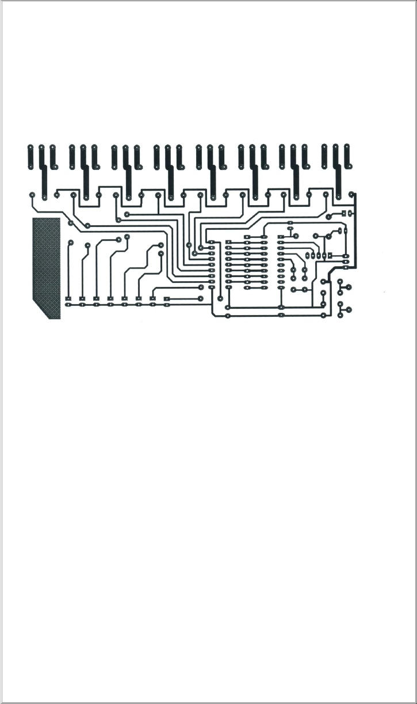

**COMPONENT LAYOUT**

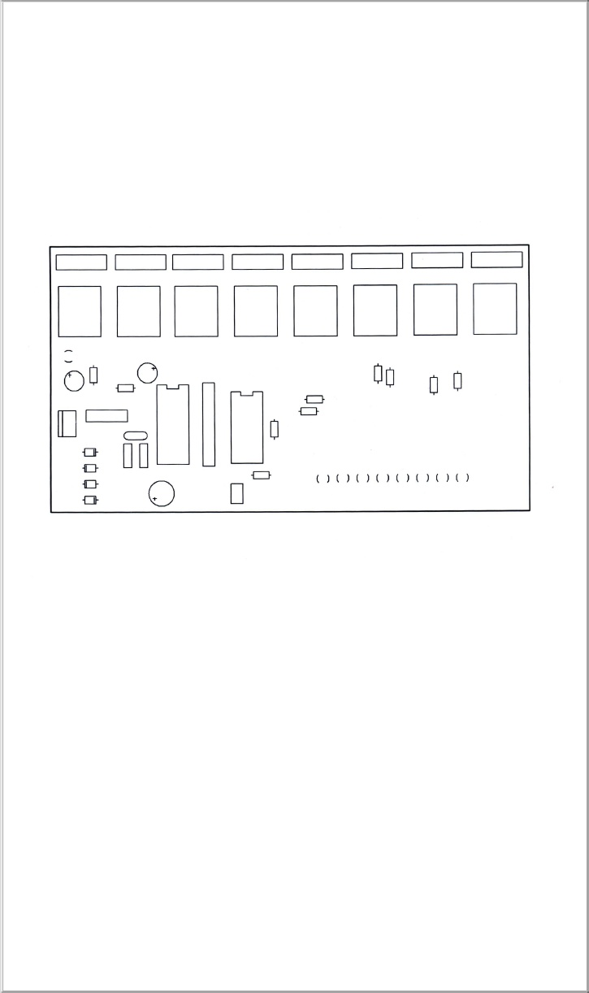

**PCB PREPARATION TECHNIQUES**

**PCB Preparation**

You need to generate a positive (copper black) UV translucent art work film. Youwill never get a good board without good art work, so it is important to get the best possible quality at this stage. The most important thing is to get a clear sharp image with avery solid opaque black. Art work is done using ORCAD software. It is absolutelyessential that your PCB software prints holes in the middle of pads, which will act ascentre marks when drilling. It is virtually impossible to accurately hand-drill boardswithout these holes. If you are looking to buy PCB software at any cost level and want todo hand-protyping of boards before production, check that this facility is available whendefining pad and line shapes, the minimum size recommended (through-linking holes) for reliable result is 50 mil, assuming 0.8mm drill size; 1 mil=(1/1000)

th

of an inch. You cango smaller drill sizes, but through linking will be harder. 65 mil round or square pads for normal components.ICs, with 0.8 mm hole, will allow a 12.5mil, down to 10mil if you really needto. Center-to-centre spacing of 12.5 mil tracks should be 25 mil-slightly less may b possible if your printer can manage it. Take care to preserve the correct diagonal track-track spacing on mitered corners; grid is 25 mil and track width 12.5mil. The art work must be printed such that the printed side is in contact with PCB surface when exposing,to avoid blurred edges. In practice, this means that if you design the board as seen fromthe component side, the bottom (solder side) layer should be printed the ‘correct’ wayround, and top side of the double-sided board must be printed mirrored.

**Etching**

Ferric chloride etchant is a messy stuff, but easily available and cheaper than mostalternatives. It attacks any metal including stainless steel. So when setting up a PCBetching area, use a plastic or ceramic sink, with plastic fitting and screws wherever  possible, and seal any metal screws with silicon. Copper water pipes may be splashed ordripped-on, so sleeve or cover them in plastic; heat-shrink sleeving is great if you areinstalling new pipes. Fume extraction is not normally required, although a cover over thetank or tray when not in use is a good idea. You should always use the hex hydrate type of ferric chloride, which should be dissolved in warm water until saturation. Adding ateaspoon of table salt helps to make the etchant clearer for easier inspection. Avoidanhydrous ferric chloride. It creates a lot of heat when dissolved. So always add the powder very slowly to water; do not add water to the powder, and use gloves and safetyglasses. The solution made from anhydrous ferric chloride doesn’t etch at all, so you needto add a small amount of hydrochloric acid and leave it for a day or two. Always takeextreme care to avoid splashing when dissolving either type of ferric chloride, acid tendsto clump together and you often get big chunks coming out of the container and splashinginto the solution. It can damage eyes and permanently stain clothing. If you are makingPCBs in a professional environment where time is money you should get a heated bubble-etch tank. With fresh hot ferric chloride, the PCB will etch in well under 5 mins. Fastetching produces better edge-quality and consistent line widths. If you aren’t using a bubble tank, you need to agitate frequently to ensure even etching. Warm the etchant by putting the etching tray inside a larger tray filled with boiling water.

**Drilling**

If you have fiber glass (FR4) board, you must use tungsten carbide drill bits.Fiber glass eats normal high-speed steel (HSS) bits very rapidly, although HSS drills arealright for older larger sizes (> 2mm). Carbide drill bits are available as straight-shank or thick-shank. In straight shank, the hole bit is the diameter of the hole, and in thick shank,a standard size (typically about 3.5 mm) shank tapers down to the hole size. The straight-shank drills are usually preferred because they break less easily and are usually cheaper.The longer thin section provides more flexibility. Small drills for PCB use usually comewith either a set of collets of various sizes or a three-jaw chuck. Sometimes the 3-jawchuck is an optional extra and is worth getting for the time it saves on changing collets.For accuracy, however, 3-jaw chucks are not brilliant, and small drill sizes below 1 mmquickly formed grooves in the jaws, preventing good grip. Below 1 mm, you should usecollets, and buy a few extra of the smallest ones; keeping one collets per drill size as usinga larger drill in a collets will open it out and it no longer grips smaller drills well. You

need a good strong light on the board when drilling, to ensure accuracy. A dichroichalogen lamp, under run at 9V to reduce brightness, can be mounted on a microphonegooseneck for easy positioning. It can be useful to raise the working surface above 15 cmabove the normal desk height for more comfortable viewing. Dust extraction is nice, butnot essential and occasional blow does the trick! A foot-pedal control to switch the drill‘off’ and ‘on’ is very convenient, especially when frequently changing bits. Avoid holesizes less than 0.8 mm unless you really need them. When making two identical boards,drill them both together to save time. To do this, carefully drill a 0.8 mm whole in the padnear each corner of each of the two boards, getting the center as accurately as possible.For larger boards, drill a hole near the centre of each side as well. Lay the boards on thetop of each other and insert a 0.8 mm track pin in two opposite corners, using the pins as pegs to line the PCBs up. Squeeze or hammer the pins into boards, and then into theremaining holes. The two PCBs are now ‘nailed’ together accurately and can be drilledtogether.

**Soldering**

Soldering is the joining together of two metals to give physical bonding and goodelectrical conductivity. It is used primarily in electrical and electronic circuitry. Solder is acombination of metals, which are solid at normal room temperatures and become liquid between 180 and 200 degree Celsius. Solder bonds well to various metals, and extremelywell to copper. Soldering is a necessary skill you need to learn to successfully buildelectronics circuits. To solder you need a soldering iron. A modern basic electricalsoldering iron consists of a heating element, a soldering bit (often called a tip), a handleand a power cord. The heating element can be either a resistance wire wound around aceramic tube, or a thick film resistance element printed on to a ceramic base. The elementis then insulated and placed into a metal tube for strength and protection. This is thenthermally insulated from the handle. The heating element of soldering iron usuallyreaches temperatures of around 370 to 400 degree Celsius (higher than need to melt thesolder). The strength or power of a soldering iron is usually expressed in watts. Ironsgenerally used in electronics are typically in the range of 12 to 25 watts. Higher powerediron will not run hotter. Most irons are available in a variety of voltages; 12V, 24V, 115Vand 230V are most popular. Today most laboratories and repair shops use soldering irons,which operate at 24V. You should always use this low voltage where possible, as it is much safer. For advanced soldering work, you will need a soldering iron with temperaturecontrol. In this type of soldering irons, the temperature may be usually set between 200and 450 degree Celsius.Many temperature control soldering iron designed for electronics have a power rating of around 40 to 50 watt. They will heat fast and give enough power for operation, but are mechanically small.You will occasionally see gas-powered soldering irons which use butane rather than the main electrical supply to operate. They have a catalytic element which oncewarmed up, continues to glow hot when gas passes over them. Gas powered solderingirons are designed for occasional ‘on the spot’ used for quick repairs, rather than for mainstream construction or for assembly work.Currently, the best commonly available, workable, and safe solder alloy is63/37. That is, 63% lead, 37% tin. It is also known as eutectic solder. Its most desirablecharacteristic is that it solids (‘pasty’) state, and its liquid state occur at the sametemperature -361 degree Fahrenheit. The combination of 63% lead and 37% tin melts atthe lowest possible temperature. Nowadays there is tendency to move to use lead freesolders, but it will take years until they catch on normal soldering work. Lead free soldersare nowadays available, but they are generally more expensive or harder to work on thantraditional solders that they have lead in them.The metals involved are not the only things to consider in a solder. Flux is vitalto a good solder joint. Flux is an aggressive chemical that removes oxide and impuritiesfrom the parts to be soldered. The chemical reactions at the point(s) of connection musttake place for the metal to fuse. RMA type flux (Rosin Mildly Active) is the leastcorrosive of the readily available materials, and provides an adequate oxide removal.In electronics, a 60/40 fixed core solder is used. This consists of 60% lead and40% tin, with flux cores added to the length of solder.There are certain safety measures which you should keep in mind whensoldering. The tin material used in soldering contains dangerous substances like lead (40-60% of typical soldering tins are lead and lead is poisonous). Also the various fumes fromthe soldering flux can be dangerous. While it is true that lead does not vaporize at thetemperature at which soldering is typically done.

When soldering, keep the room well ventilated and use a small fan or fume trap. A proper fume trap of a fan will keep the most pollution away from your face. Professionalelectronic workshops use expensive fume extraction systems to protect their workers.Those fume extraction devices have a special filter which filters out the dangerous fumes.If you can connect a duct to the output from the trap to the outside, that would be great.Always wash hands prior to smoking, eating, drinking or going to the bathroom.When you handle soldering tin, your hands will pick up lead, which needs to be washedout from it before it gets to your body. Do not eat, drink or smoke while working withsoldering iron. Do not place cups, glasses or a plate of food near your working area.Wash also the table sometimes. As you solder, at times there will be a bit of spitting or sputtering. If you look you will see tiny balls of solder that shoot out and can be found on your soldering table.

**ADVANTAGES**



Cost effective and time efficient



Provides better security



Easy to construct and install



Consumes less energy and is more efficient



Increases the overall efficiency of the system



Works at higher speed



Has wider range of applications



Etc

**APPLICATIONS**



Used in communication industry



Used in process control industries



Used in defence



Used in domestic and industrial applications



Used in Data loggers



Used in the R & D industries Etc

**CONCLUSION**

As stated this project has a number of applications, from as simple as to simplify a busyman’s life to as complicated as in big industries where automation of multiple unitssimultaneously is a necessity. Depending upon the desired intensity or speed of the device bluetooth module with high specification is used. This will be useful at all the placeswhere the switching action of the device includes states between on and off.

**REFERENCES**

•

Communications and analysis by Ann Hyde

•

Intel data Handbook

•

[www.google.com](http://www.google.com/)

•

[www.microchip.com](http://www.microchip.com/)

•

[www.epanorama.com](http://www.epanorama.com/)

•

[www.bluetooth.org](http://www.bluetooth.org/)

•

Pic Micro Mid Range MCU Family Reference Manual, Microchip, 1997

•

[www.iee.org](http://www.iee.org/)

•

Microcontrollers (Theory and Applications) by Ajay V Deshmukh

•

Advanced Microprocessors and Peripherals by A K Ray & Burchandi